Assignment: (Day-2) Network Topologies

1. Bus Topology
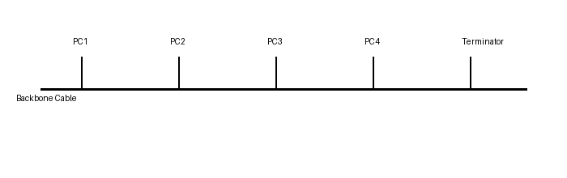
Example: Bus topology was commonly used in early Ethernet (10Base2) networks in small offices and computer labs.

2. Star Topology (Cisco Packet Tracer Example)
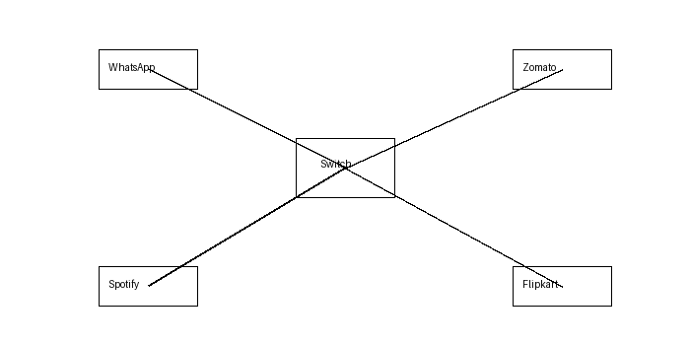
This diagram represents a switch connected to four PCs named WhatsApp, Zomato, Spotify, and Flipkart. Replace it with your Packet Tracer screenshot if required by your trainer.

3. Ring Topology
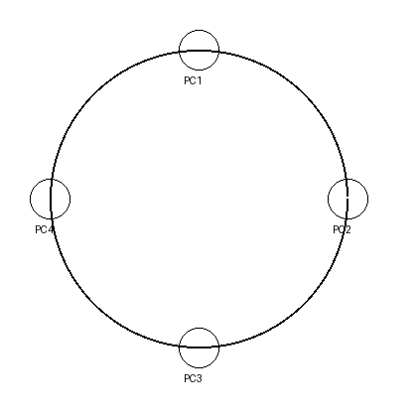
In a ring topology, each device is connected to two neighboring devices, forming a closed loop. Data travels in one direction around the ring until it reaches the destination device, reducing data collisions.

4. Mesh vs Star Topology
Topology | Advantages | Disadvantages
Mesh | 1. High reliability  2. Multiple paths | 1. Expensive  2. Complex setup
Star | 1. Easy to manage  2. Easy to expand | 1. Switch failure affects all  2. More cabling

